Aura: An AI-based Carbon Footprint Calculator and Short-Term Predictor for India

Team Members -
Omkar Rasal - MITU21BTIT0042 - rasalomkar40@gmail.com
Tushar Lalwani - MITU22BTIT0095 - tusharlalwani40@gamil.com
Neil Shah - MITU23BTITD006 - shahneil13@gmail.com
Ajinkya Sathe - MITU21BTIT0005 - ajinkyasathe456@gmail.com
Guide - Prof. Rupali Bhatkhande
Group ID: LYIT14
Class: LY
Introduction –
Greenhouse gas emissions from everyday human activities contribute to global climate change. Personal carbon calculators help individuals understand their contributions and motivate reductions, but many available tools use global or country-agnostic emission factors that reduce regional relevance. India’s electricity mix, fuel characteristics, and consumption patterns vary across regions; therefore, a locally-seeded approach improves accuracy and trustworthiness. Aura is a prototype platform that provides a:
(1) production-like user experience for tracking individual footprints
(2) uses a seeded emission-factor database curated for India
(3) implements a lightweight, explainable predictor for short-term monthly forecasts.
Problem Statement -
The Problem of Personalization: Existing carbon footprint calculators are generic, failing to provide advice tailored to a user's specific lifestyle and habits. The Problem of Engagement: Current tools are static, offering no way to track progress over time, which makes it difficult to stay motivated and see the results of one's efforts.
Proposed Solution –
1. A personalized dashboard to accurately calculate an individual's carbon footprint using a live, scientific API for emission factors.
2. Progress tracking and data visualization through simple charts and graphs to monitor trends and the results of positive changes over time.
Category | Technology / Tool | Description
FRONTEND | Next.js 14 | React framework with SSR (Server-Side Rendering) & API routes
 | React 18 | UI library
 | TypeScript | Type-safe JavaScript
 | Tailwind CSS | Styling framework
 | shadcn/ui | UI component library
 | Recharts | Data visualization
BACKEND | Node.js | Runtime environment
 | Next.js API Routes | Backend APIs
 | Prisma ORM | Database management
 | PostgreSQL / SQLite | Database
3. An AI-powered forecasting engine to predict future emissions and provide personalized, high-impact recommendations for reduction
Tools Used -
RESULTS -
Results show that Aura’s forecasting module achieves low RMSE and MAE scores for short-term trends, outperforming naive and static baselines. The transparent nature of the regression model helps users understand emission drivers and seasonal variations. Qualitative user feedback highlighted the platform’s usability and contextual clarity
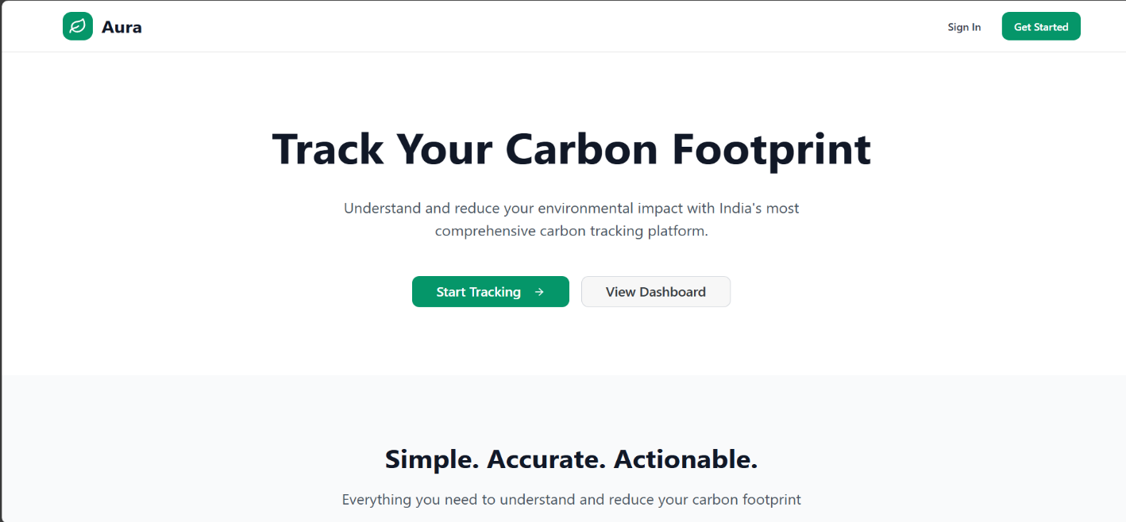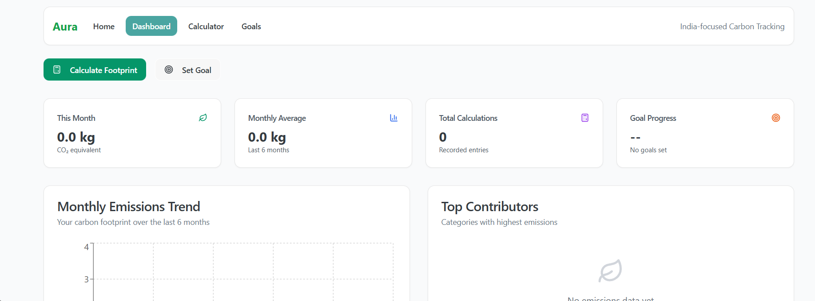
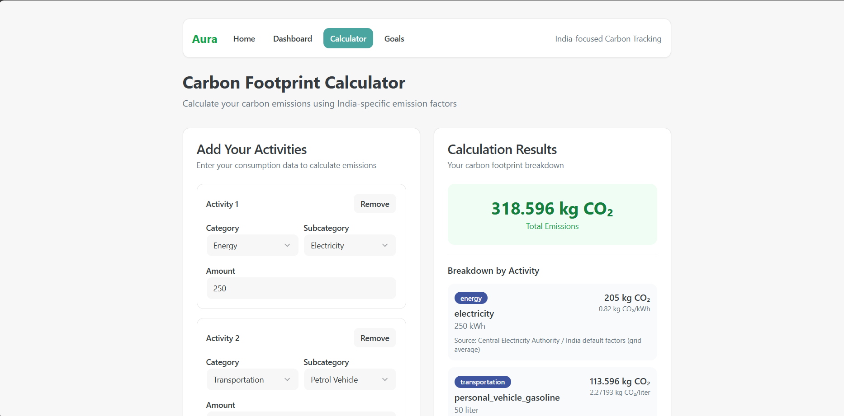
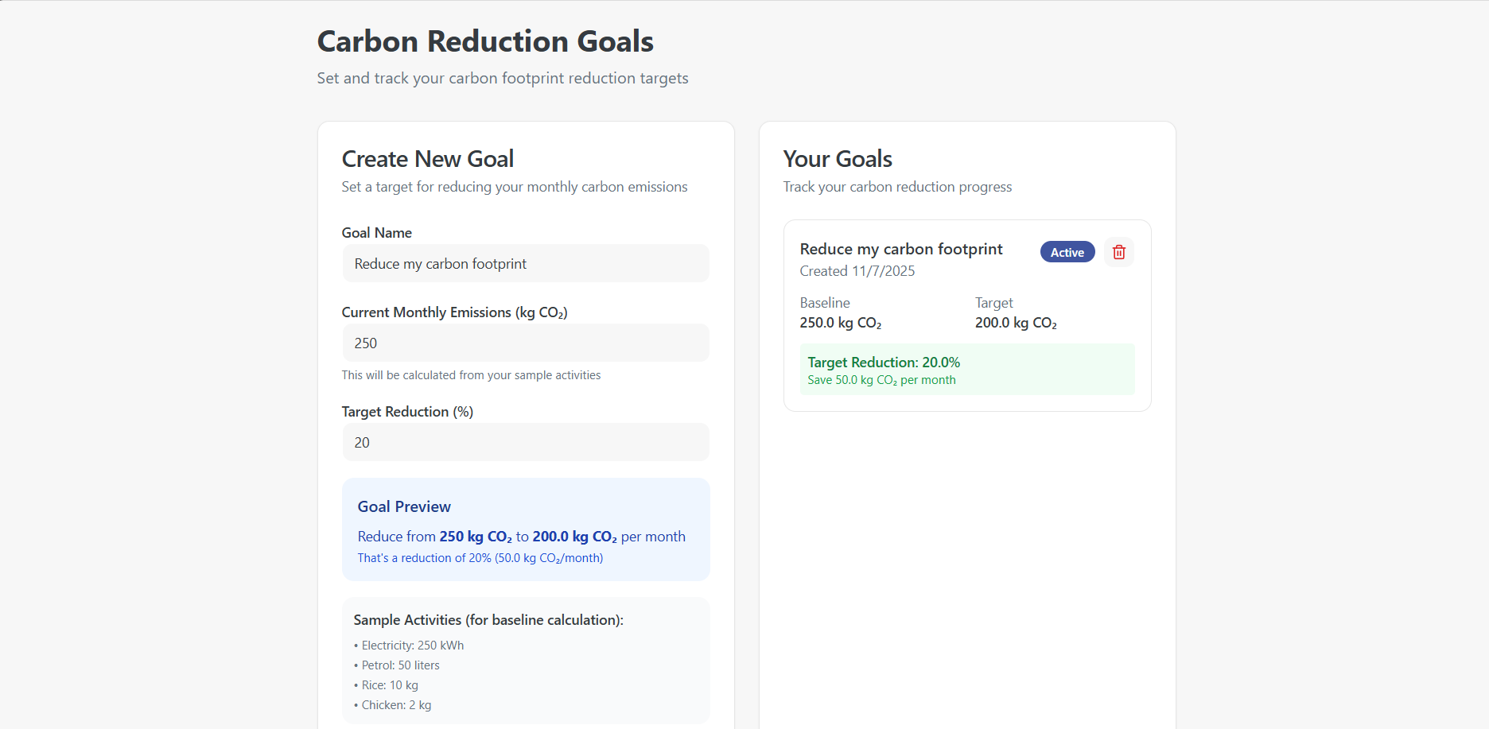
Future Scope –
1) Expand the calculator to include more lifestyle categories, such as different home energy sources and personal waste recycling, for a more complete footprint analysis.
2) Introduce automated tracking by securely connecting with other apps (like travel or utility services) to reduce manual data entry for the user.

